You can refer: <https://istio.io/latest/docs/ops/integrations/kiali/>

You can install Kiali:

* kubectl apply -f <https://raw.githubusercontent.com/istio/istio/release-1.25/samples/addons/kiali.yaml>





Finally you can run:

* istioctl dashboard kiali



You will be able to see a dashboard:

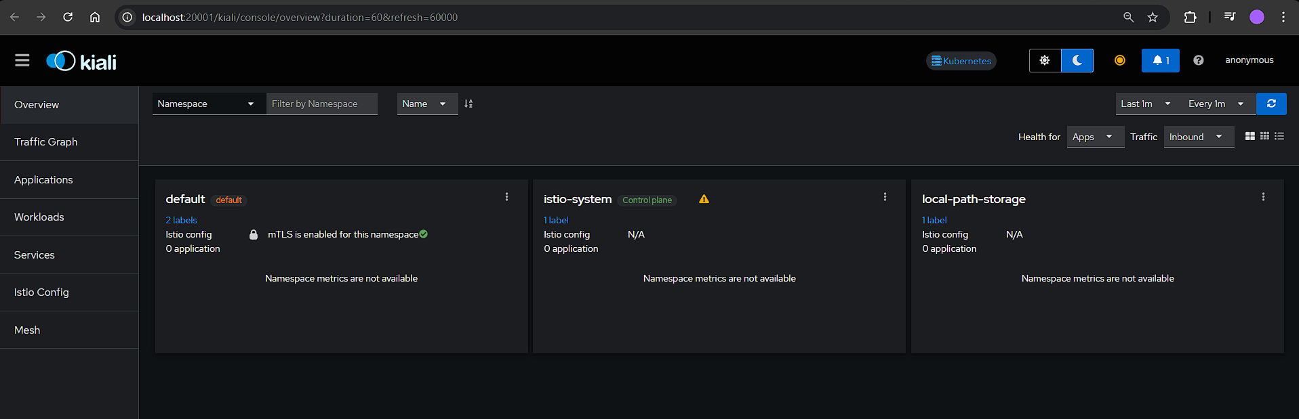

You can connect your applications and this is how you can add observability